**Implement Hierachical clustering (R / Orange )**

1. Single linkage
2. Complete linkage
3. Average Linkage

**Analysis Visualization:**

Visualized with hclust, geom_point, scatterplot, heatmap, corrplot::corrplot.

**Dataset:**

**Play.csv (Cluster of paly depend on different weather);**

**Iris.csv (3 Species clustering depend on features);**

**Animal.csv (Animal clustering depend on couple features).**

**Play clustering**

> play <- readWorksheetFromFile("C:/Users/Wanwan Zhang/Desktop/2016FALL/ADS/4/play.xlsx", sheet = 1)

> # complete linkage

> clusters <- hclust(dist(play[, 2:3]))

> plot(clusters)

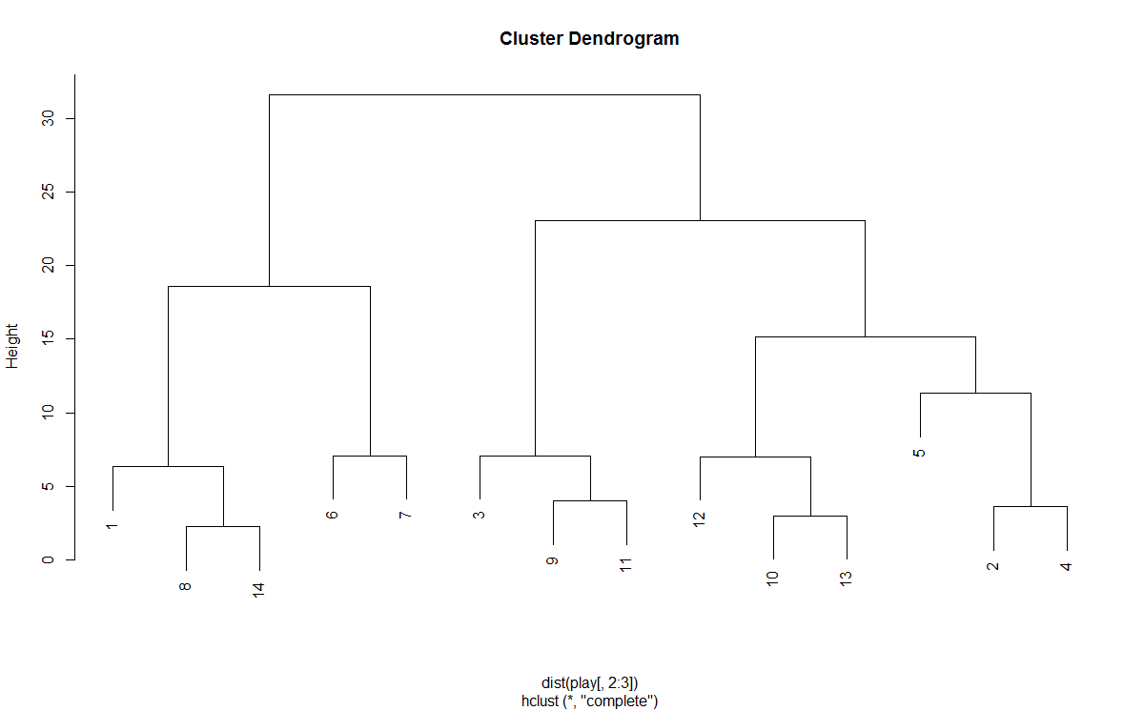

> clusterCut <- cutree(clusters, 2)

> table(clusterCut, play$Decision)

clusterCut dont_play play

1 3 2

2 2 7

> # mean/average linkage

> clusters <- hclust(dist(play[, 2:3]), method = 'average')

> plot(clusters)

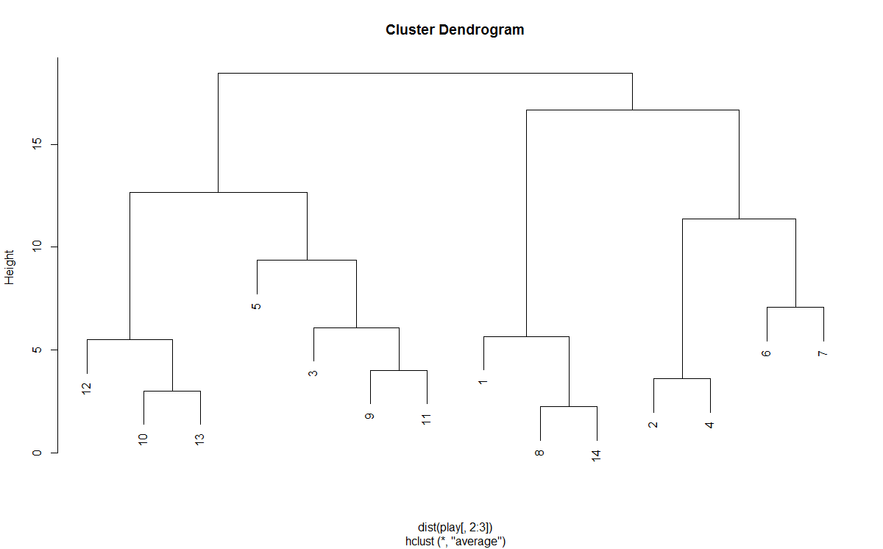

> clusterCut <- cutree(clusters, 2)

> table(clusterCut, play$Decision)

clusterCut dont_play play

1 3 4

2 2 5

|  |
| --- |
| > ggplot(play, aes(play$Temperature, play$Humidity, color = play$Decision)) +  + geom_point(alpha = 0.4, size = 3.5) + geom_point(col = clusterCut) +  + scale_color_manual(values = c('black', 'red', 'green')) |
|  |
|  |

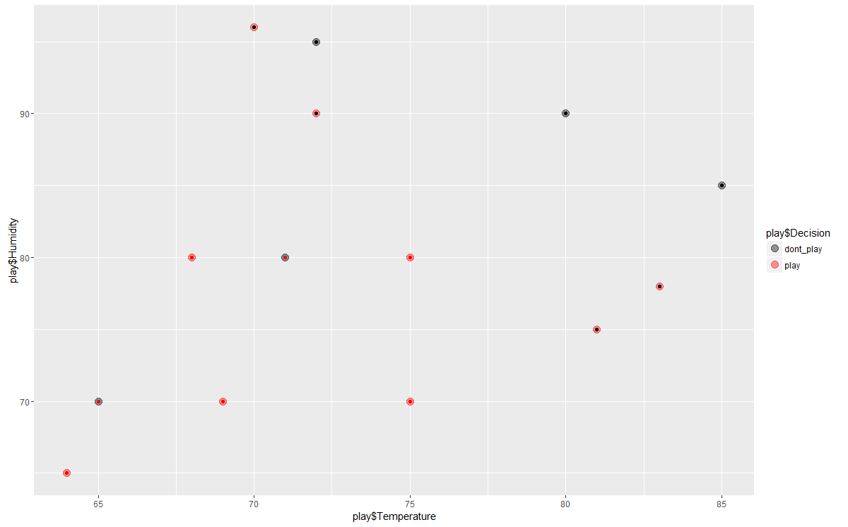

Implement in Orange：

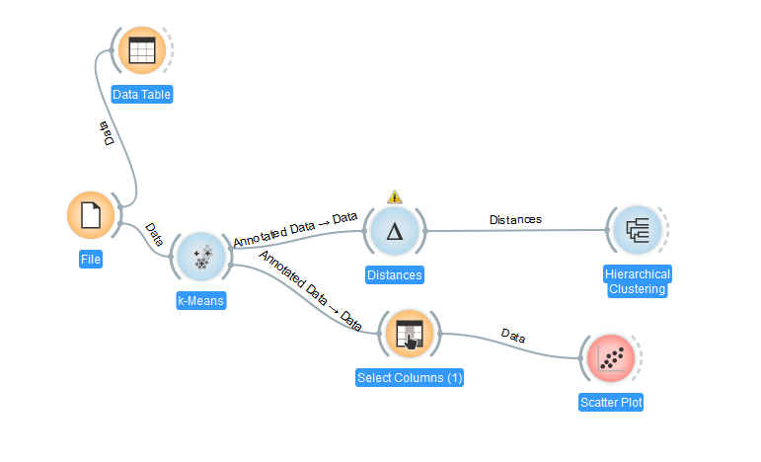

Complete linkage:

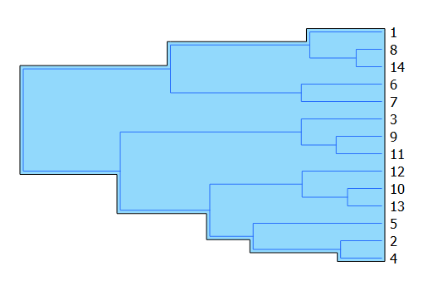

Average Linkage:

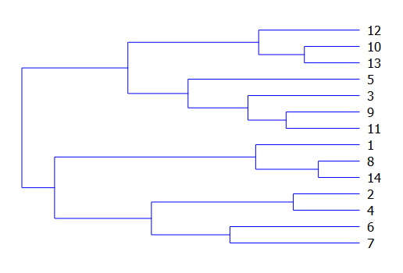

K-means to set the 2 clusters and get the scatterplot to show the different features and number of each cluster.

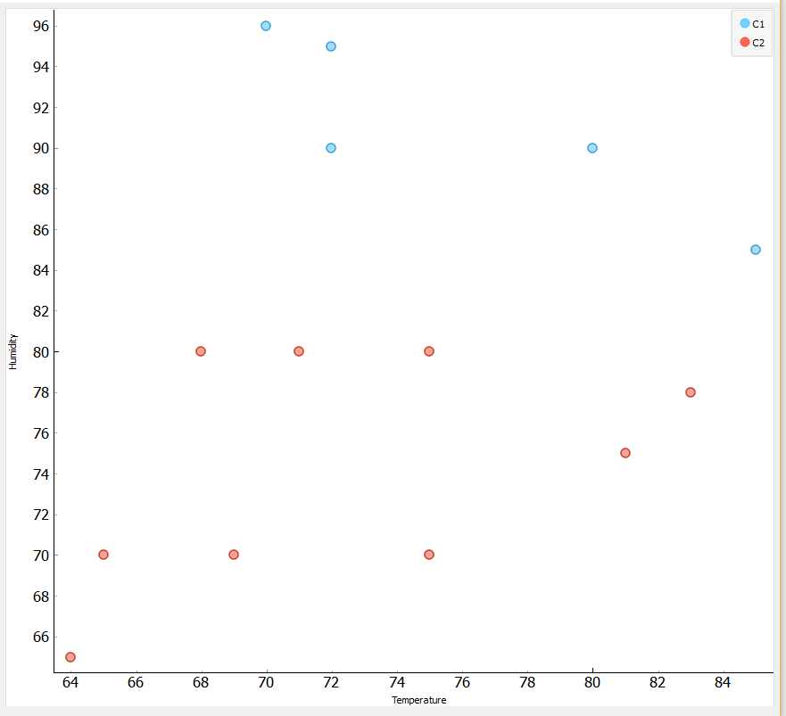

**Iris hierarchical clustering**

> library(ggplot2)

> # complete linkage

> clusters <- hclust(dist(iris[, 3:4]))

> plot(clusters)

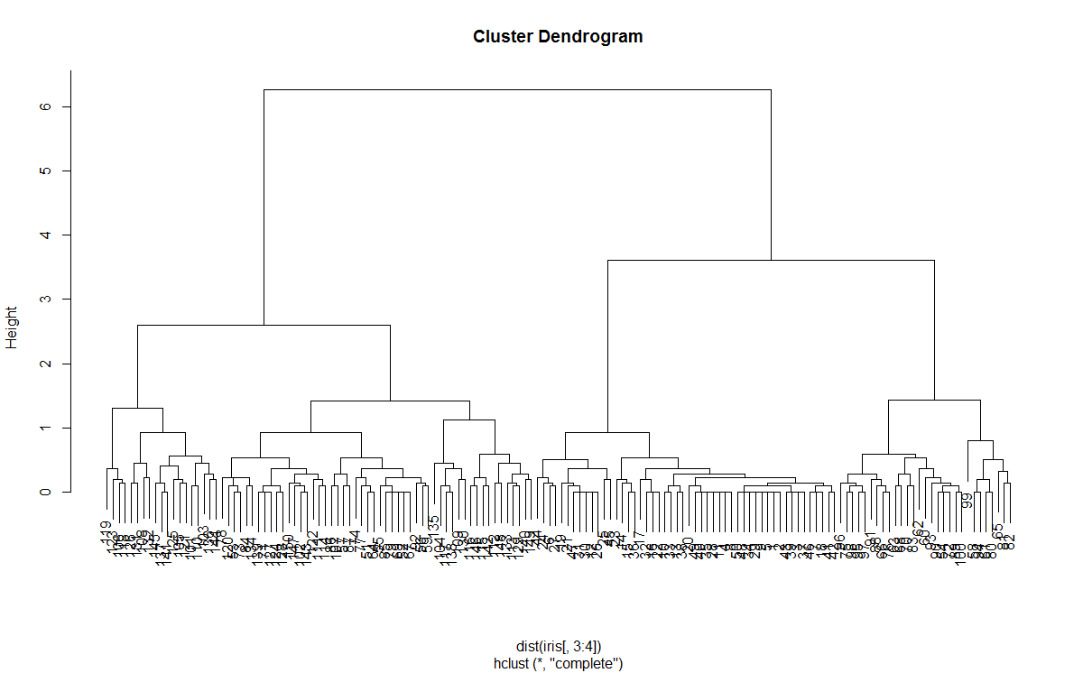

> clusterCut <- cutree(clusters, 3)

> table(clusterCut, iris$Species)

clusterCut setosa versicolor virginica

1 50 0 0

2 0 21 50

3 0 29 0

> # mean/average linkage

> clusters <- hclust(dist(iris[, 3:4]), method = 'average')

> plot(clusters)

> clusterCut <- cutree(clusters, 3)

> table(clusterCut, iris$Species)

clusterCut setosa versicolor virginica

1 50 0 0

2 0 45 1

3 0 5 49

> ggplot(iris, aes(Petal.Length, Petal.Width, color = iris$Species)) +

+ geom_point(alpha = 0.4, size = 3.5) + geom_point(col = clusterCut) +

+ scale_color_manual(values = c('black', 'red', 'green'))

>

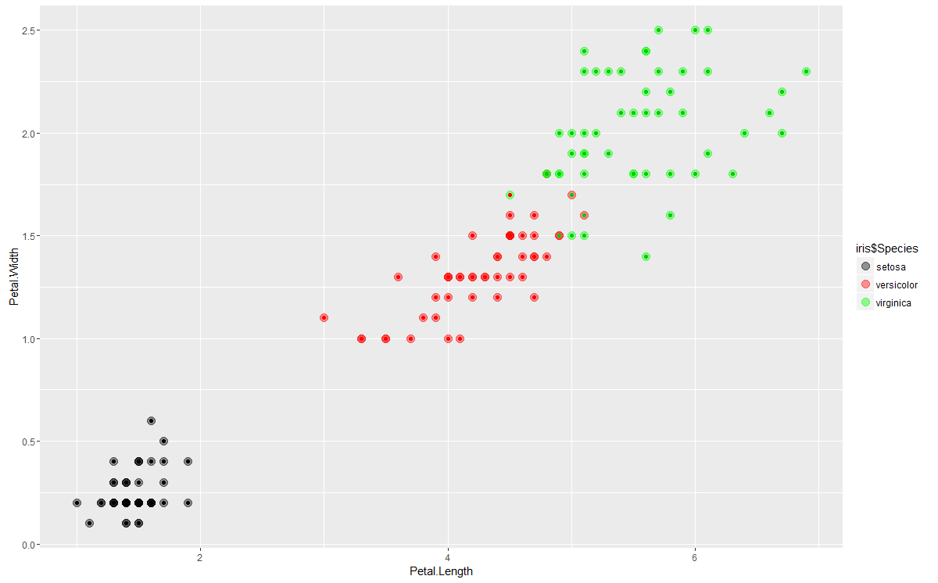

Implement in Orange :



Complete linkage:

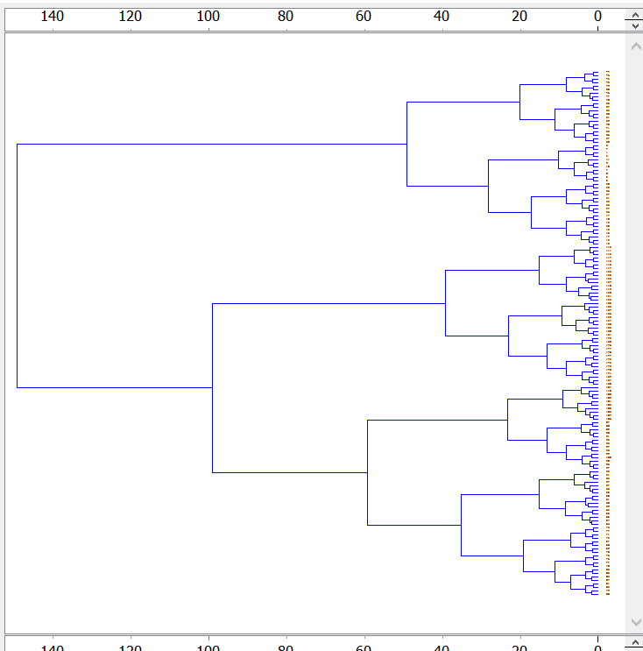

Average linkage:

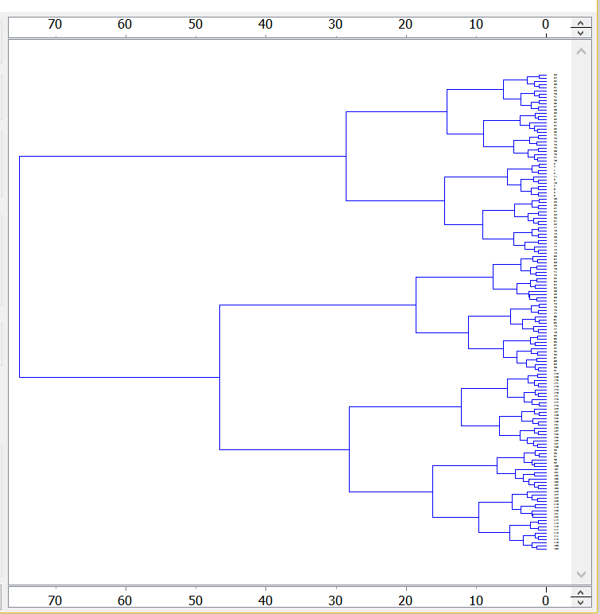

K-means to set the 2 clusters and get the scatterplot to show the different features and number of each cluster.

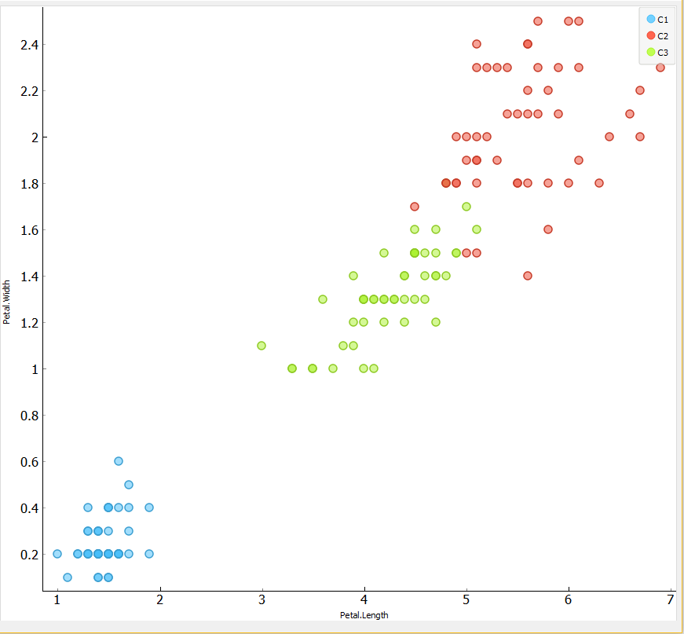

**Animal hierarchical clustering**

**animals---attributes-of-animals**

> animals <- cluster::animals

>

> colnames(animals) <- c("warm-blooded",

+ "can fly",

+ "vertebrate",

+ "endangered",

+ "live in groups",

+ "have hair")

>

> dend_r <- animals %>% dist(method = "man") %>% hclust(method = "ward.D") %>% as.dendrogram %>% ladderize %>%

+ color_branches(k=4)

>

> dend_c <- t(animals) %>% dist(method = "man") %>% hclust(method = "com") %>% as.dendrogram %>% ladderize%>%

+ color_branches(k=3)

>

>

> # some_col_func <- function(n) rev(colorspace::heat_hcl(n, c = c(80, 30), l = c(30, 90), power = c(1/5, 1.5)))

> # some_col_func <- colorspace::diverge_hcl

> # some_col_func <- colorspace::sequential_hcl

> some_col_func <- function(n) (colorspace::diverge_hcl(n, h = c(246, 40), c = 96, l = c(65, 90)))

>

>

> # par(mar = c(3,3,3,3))

> # library(gplots)

> gplots::heatmap.2(as.matrix(animals-1),

+ main = "Attributes of Animals",

+ srtCol = 35,

+ Rowv = animals,

+ Colv = t(animals),

+ trace="row", hline = NA, tracecol = "darkgrey",

+ margins =c(6,3),

+ key.xlab = "no / yes",

+ denscol = "grey",

+ density.info = "density",

+ col = some_col_func

+ )

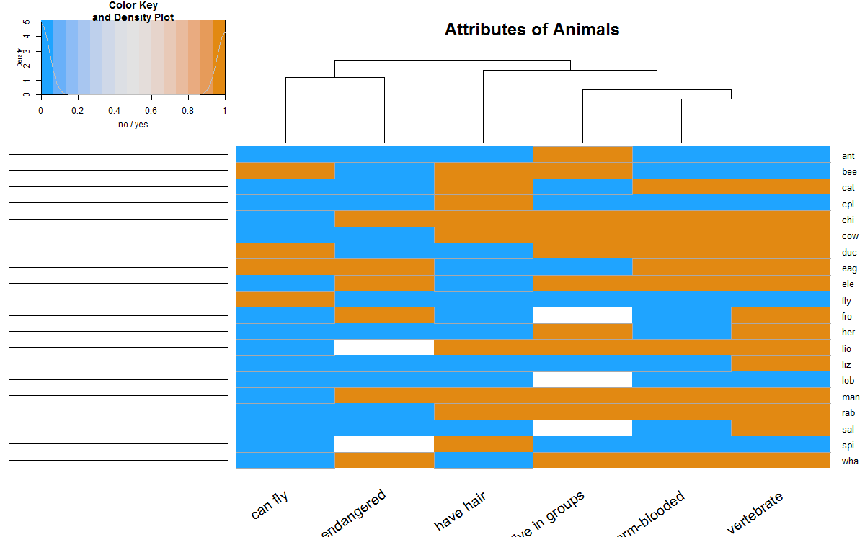

> hclust_methods <- c("ward.D", "single", "complete", "average", "mcquitty",

+ "median", "centroid", "ward.D2")

> animals_dendlist <- dendlist()

> for(i in seq_along(hclust_methods)) {

+ tmp_dend <- animals %>% dist(method = "man") %>%

+ hclust(method = hclust_methods[i]) %>% as.dendrogram

+ animals_dendlist <- dendlist(animals_dendlist, tmp_dend)

+ }

> names(animals_dendlist) <- hclust_methods

> # votes.repub_dendlist

> cophenetic_cors <- cor.dendlist(animals_dendlist)

> corrplot::corrplot(cophenetic_cors, "pie", "lower")

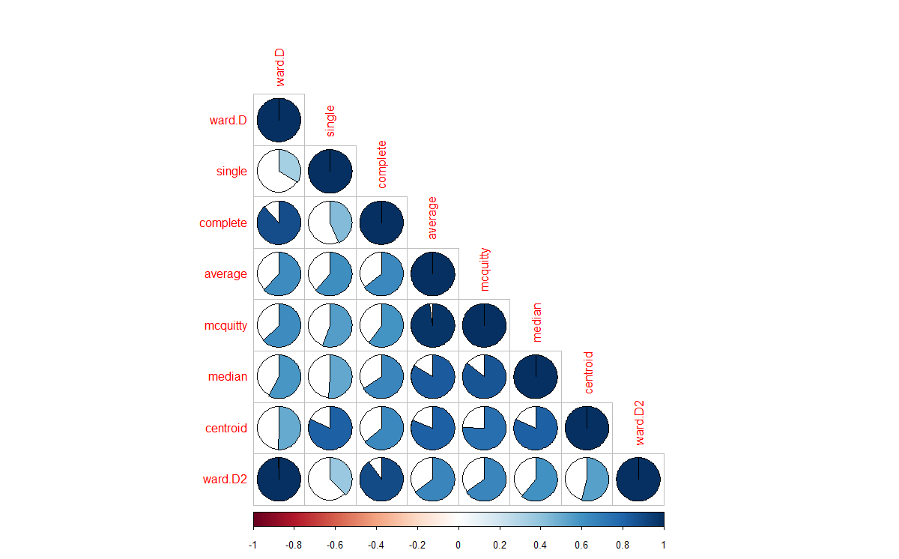

> remove_median <- dendlist(animals_dendlist, which = c(1:8)[-6] )

> FM_cors <- cor.dendlist(remove_median, method = "FM_index", k = 4)

> corrplot::corrplot(FM_cors, "pie", "lower")

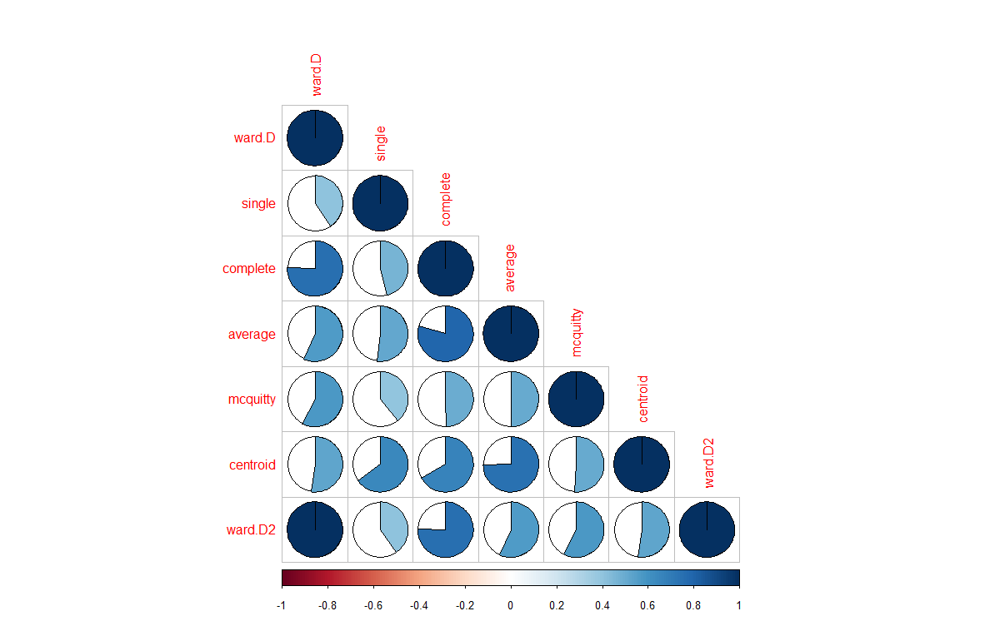

Implementing in Orange

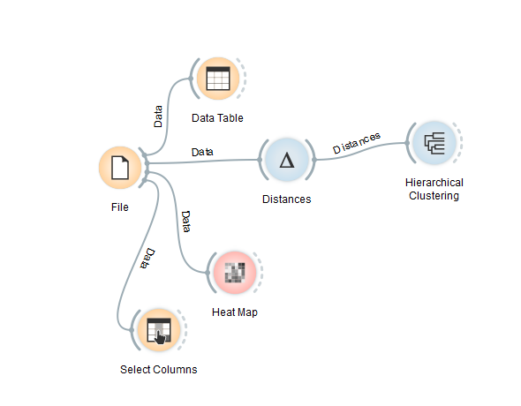

Get colorspace heatmap

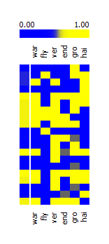

Method:Single

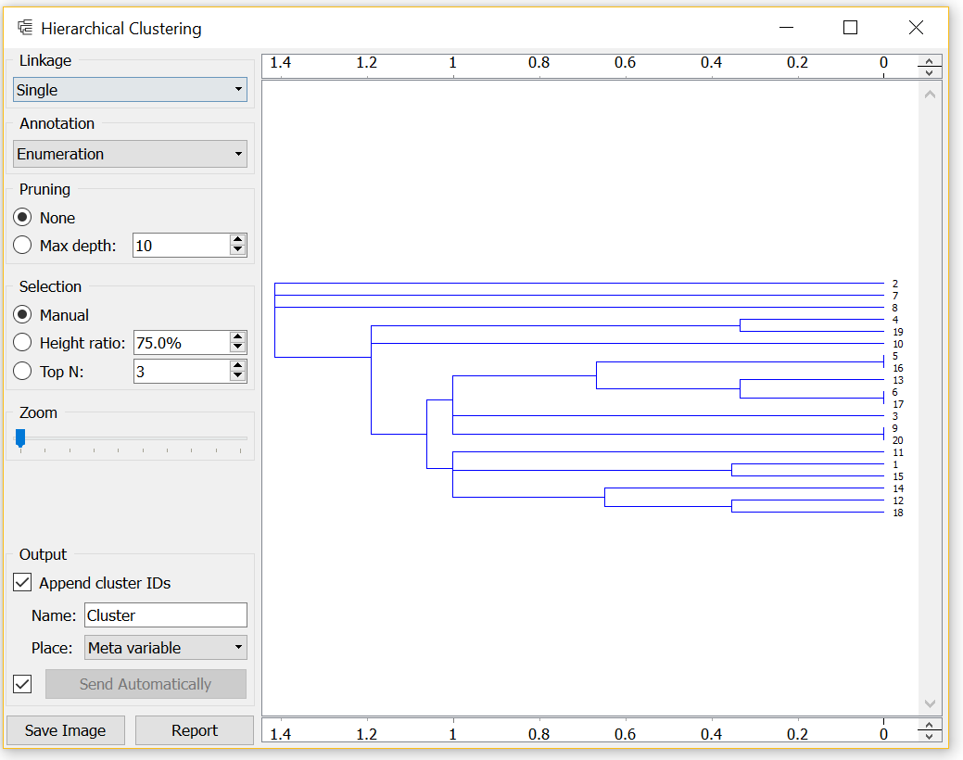

Average linkage：

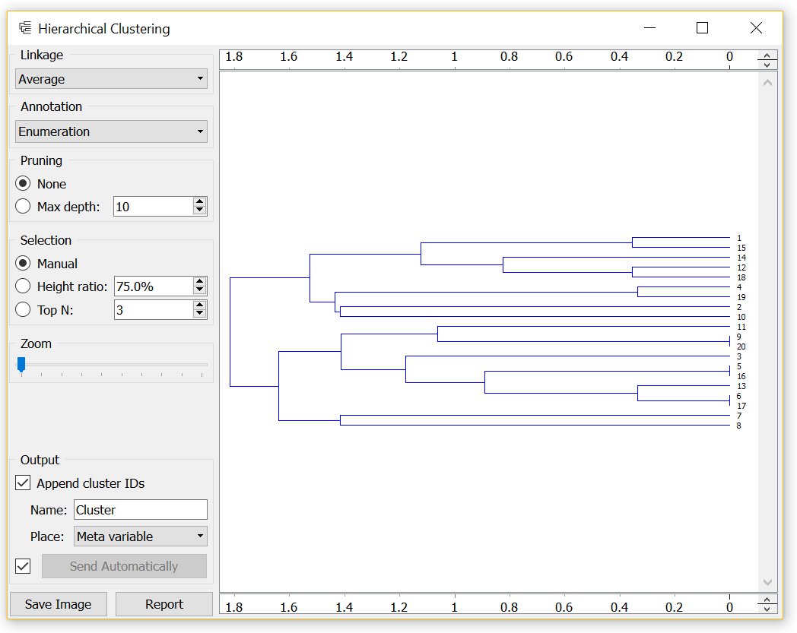

Complete linkage

